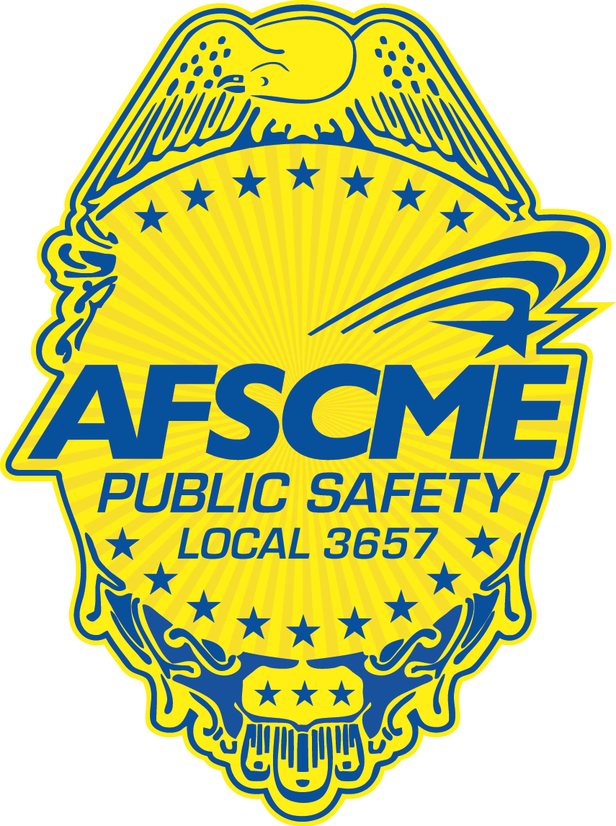../Art/AFSCME%20Local%203657%20Badge%20Full%20Color.wmf

*AFSCME* Local 3657

EXECUTIVE BOARD

*We Protect New Hampshire*

OFFICIAL UNION DOCUMENT

November 19, 2020

**The Executive Board**

**President:**

**Norma Traffie**

**Hillsborough County Sheriff**

[**ntraffie@afscme3657.org**](mailto:ntraffie@afscme3657.org)

**Northern Vice President:**

**Vacant**

**Southern Vice President:**

**Matthew Judge**

**Hollis Police Department**

[**mjudge@afscme3657.org**](mailto:mjudge@afscme3657.org)

**Chief Steward:**

**David Deroche**

**Pelham Police Department**

[**dderoche@afscme3657.org**](mailto:dderoche@afscme3657.org)

**Sergeant-at-Arms:**

**Christopher Follomon**

**Hillsborough County Sheriff**

[**cfollomon@afscme3657.org**](mailto:cfollomon@afscme3657.org)

**Treasurer:**

**Barbara Jones**

**Londonderry Police Department**

[**bajones@afscme3657.org**](mailto:bajones@afscme3657.org)

**Secretary:**

**Barbara Jones**

**Londonderry Police Department**

**Trustees:**

**Stephen Moltenbrey – Retired**

**Kevin Irwin – Retired**

***AFSCME* Council 93**

**Coordinator:**

**Steve Lyons**

[**slyons@afscme93.org**](mailto:slyons@afscme93.org)

**Staff Representative:**

**Christopher Kilmer**

[**ckilmer@afscme93.org**](mailto:ckilmer@afscme93.org)

**Staff Representative:**

**Ernie Castle**

[**ecastle@afscme93.org**](mailto:ecastle@afscme93.org)

**Staff Representative:**

**Bobby Jones**

[**bjones@afscme93.org**](mailto:bjones@afscme93.org)

***AFSCME* Local 3657**

**35 Manchester Road**

**Suite 11A - #116**

**Derry, NH 03038**

**www.afscme3657.org**

To Whom It May Concern:

AFSCME International has issued new dues rates for our members.

Therefore, effective the first pay-period after December 1, 2020 the following dues deduction rates will apply:

Full-time Part-time Part-time

(More than (Less than

12 hours/wk.) 12 hours/wk.)

Monthly: $ 41.50 $ 31.35 $ 21.20

Bi-weekly: $ 19.15 $ 14.47 $ 9.78

Weekly: $ 9.58 $ 7.23 $ 4.89

Just to reiterate our current stance on dues we, as a local, do not expect workers who are currently out on medical leave or worker’s compensation to have a payroll deduction for their union dues. In all other circumstances please proceed normally with their deductions.

If you have any questions or concerns, please notify me at:

Ntraffie@afscme3657.org or at (603) 345-3078.

Thank you.

Norma Traffie,

President

AFSCME Local 3657