TOWN OF MILFORD
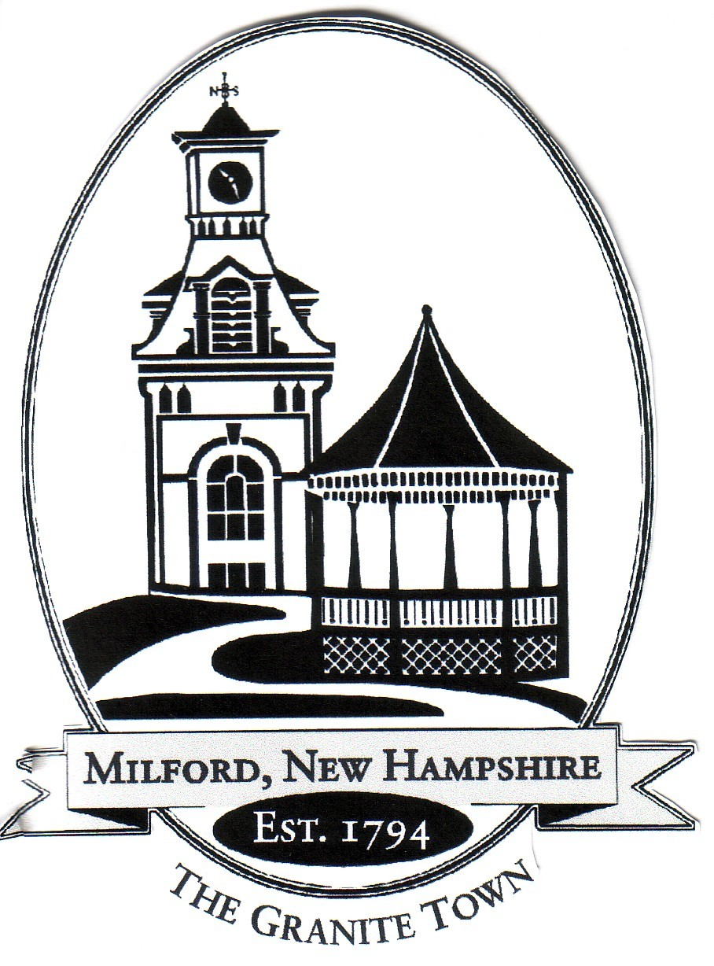
Town Hall – 1 Union Square, Milford, NH 03055-4240

Policy Regarding Work Hours and Overtime Requirements

The Fair Labor Standards Act (FLSA) requires that non-exempt employees MUST be paid for any and all hours worked. It makes no provisions for employees who voluntarily wish to start their work day early or end their work day late in order to complete unfinished tasks. The law requires that the employer MUST pay wages for all time an employee is at his/her work station – whether or not this time is voluntary on the part of the employee.
As such, it is the policy of the Milford Board of Selectmen that employees MAY NOT and MUST NOT work ANY hours beyond their regularly-scheduled work hours without the explicit, prior approval of their supervisor. An employee MAY NOT work and NOT get paid for this work.
This Federal Law and the Board of Selectmen policy as outlined above will be absolutely and strictly enforced.

Employee Acknowledgement
I acknowledge that I have received the foregoing policy; that I have read and understand the policy regarding work hours and overtime requirements as outlined above; and that I agree to abide by the fore- going policy.

Employee’s Signature Employee’s Printed Name

Date

